4.

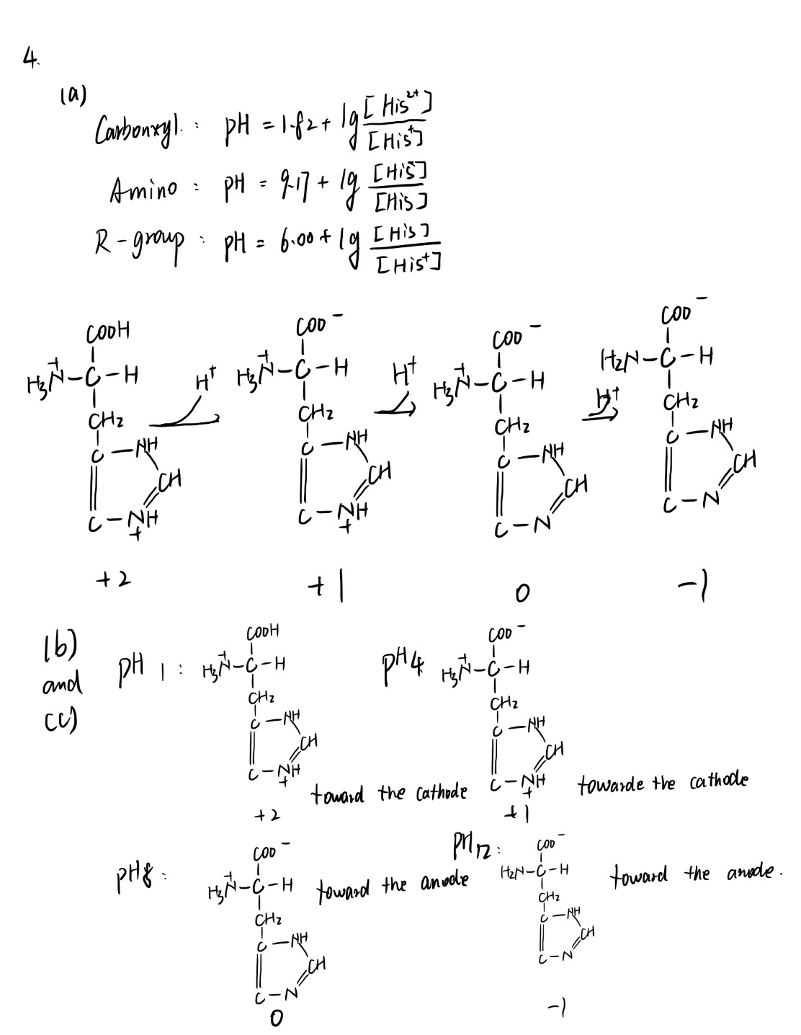

5.

(a) Lysine

(b) Arginine

(c) Valine

(d) Leucine

(e) Alanine

10. This protein has four subunits which are 160kDa subunit, 60kDa subunit and two 90kDa subunits. Two 90kDa subunits are connected by disulfide bond(s).

14.

(a) (Glu)20

(b) (Lys-Ala)3

(c) (Asn-Ser-His)5

(d) (Asn-Ser-His)5

15.

(a) step 1: 200 unit/mg; step 2: 600 unit/mg; step 3: 250 unit/mg; step 4: 4000 unit/mg;

step 5: 15000 unit/mg; step 6: 15000 unit/mg;

(b) Affinity chromatography

(c) Precipitation (pH)

(d) No, there isn’t.

We can also use electrophoresis to separate proteins in sample and check final bands on gel.

17. First: peptide C; Second: peptide B; Third: peptide A.

18. From (b) we can know that tyrosine is N-terminal amino acid and there is only one tyrosine in this peptide. Thus, from (a) we can know this peptide contains 2 Gly, 1 Leu, 1 Phe and 1 Tyr. For chymotrypsin can break peptide bonds locates carboxyl side of Phe, Tyr and Trp. So Leu is the C-terminal amino acid and Phe is on its amino side. Now, we can write down the sequence of this peptide: Tyr-Gly-Gly-Phe-Leu.